Getters and setters allow us to imply conditions on the creation of an object variable, like verifying whether an input satisfies the required conditions

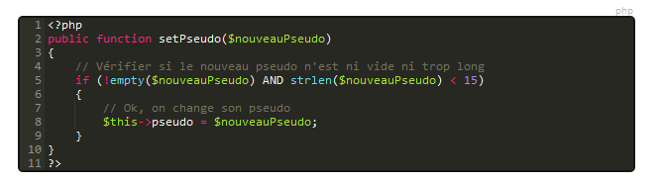

Construct is a quicker way of setting the variables

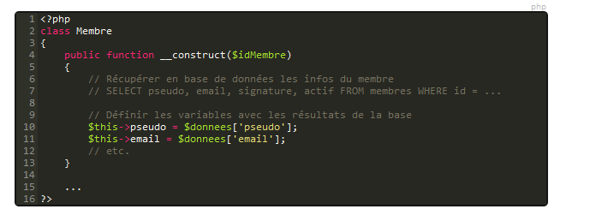

**Heritage**

The biggest asset of OOP, it allows to create new classes out of an old class, that act like extensions of that class. It’s like an instance of a class that is itself a class.

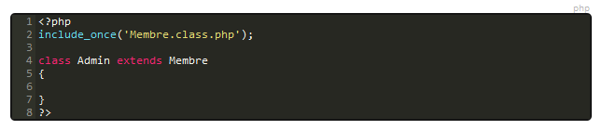

**Access rights**

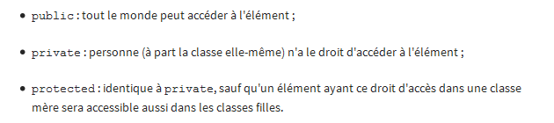

Usually, functions are public and variables are private. This is called ***encapsulation***. By doing this, using a set() function instead of just a variable assignement, we can control how the variable is created and set conditions. Moreover, we want to hide from the user how the variable is created.